USER MANUAL

Name of Application | SupportNow Leave Management System (LMS)
Engagement | Comcast
Developer / Author | 9069355 – Michael Charbbie Fuentes
Approved by | Emerlene Roberto
Version No. | V1.0
Date | April 28, 2026

This document contains internal information intended for authorized Comcast personnel only.

1. Introduction
The SupportNow Leave Management System (LMS) is a centralized application designed to simplify leave filing, approval tracking, and productivity monitoring. By combining automated approval logic with smart date controls, the system minimizes manual intervention and improves operational efficiency.
Key Benefits:
- Employees can submit leave requests, track approval status in real time, and view personal productivity scores.
- Managers gain visibility into team availability, leave schedules, and productivity to support effective workforce planning.
- Administrators receive full access to organization-wide leave data and reports, enabling consistent policy enforcement and better decision-making.
2. User Roles and Permissions
Employee
- Submit leave requests
- Track leave request status
- View personal productivity scores
- Submit downtime reports
- View payslip
Manager
- Monitor team availability
- View team leave status
- Access team productivity reports
Administrator
- Access all leave requests
- View upcoming leaves across the organization
- Access productivity reports for all agents
- Submit leave requests when required

3. Accessing the Application
- Open the LMS web portal:
- Sign in using your Comcast credentials.
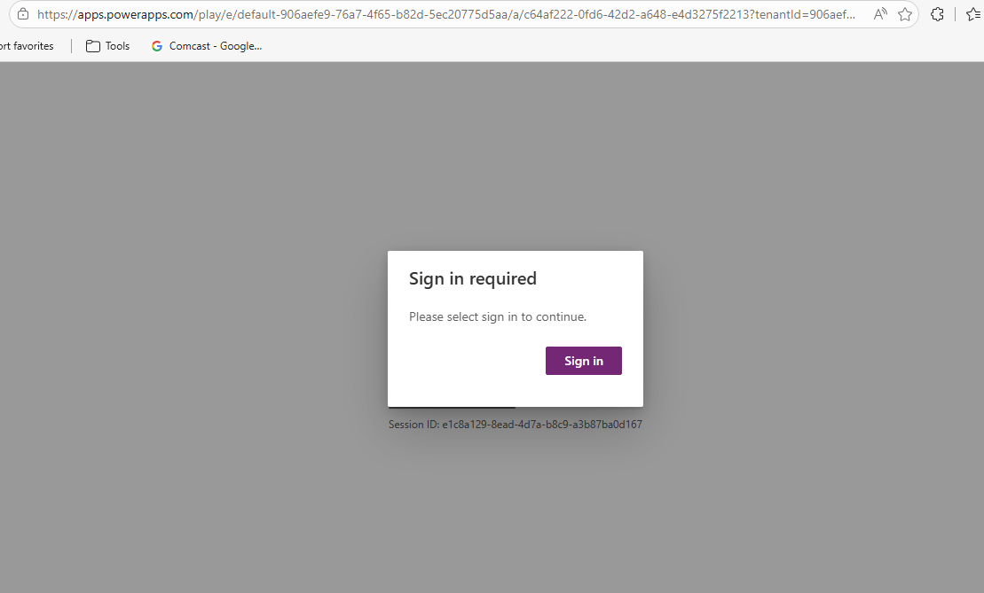
- If prompted, click Allow to grant permissions.
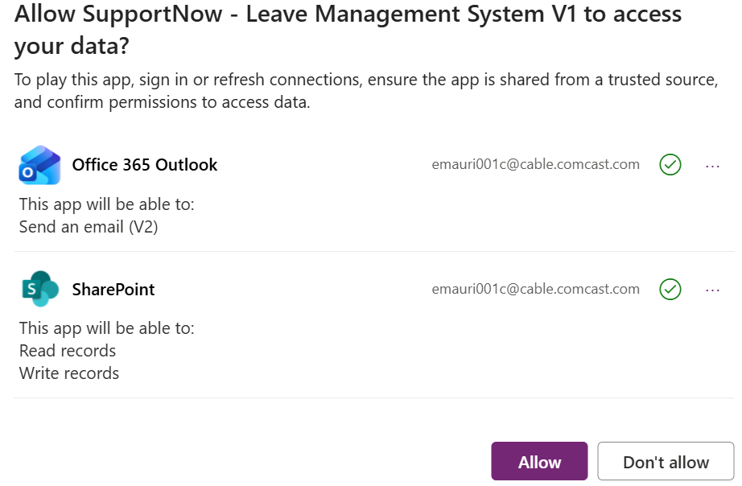
- Wait for the application to load completely.

4. Sign-In Page
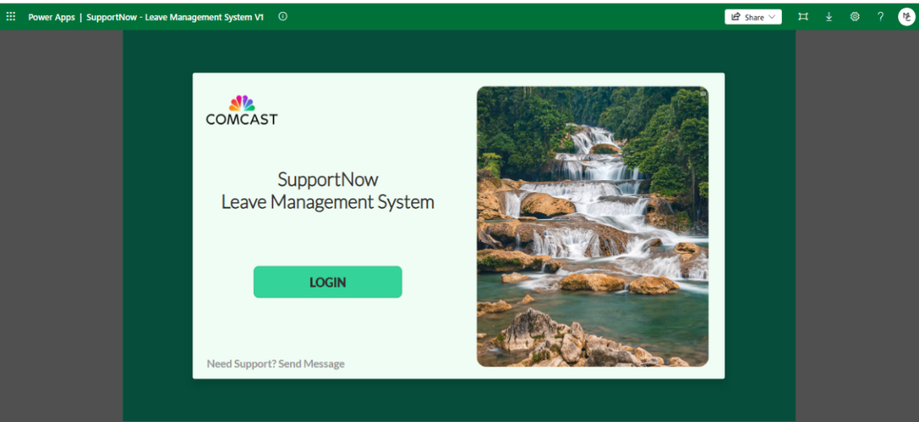
- Click Login to access the system.

- Available features depend on your assigned role (Employee, Manager, or Admin).
Additional option:
- Report an Issue / Submit Feedback
5. Agent Dashboard
The Agent Dashboard provides an overview of:
- Quick access to key actions, including File Leave
- Leave request history and status
- Submit downtime reports
- View Payslip
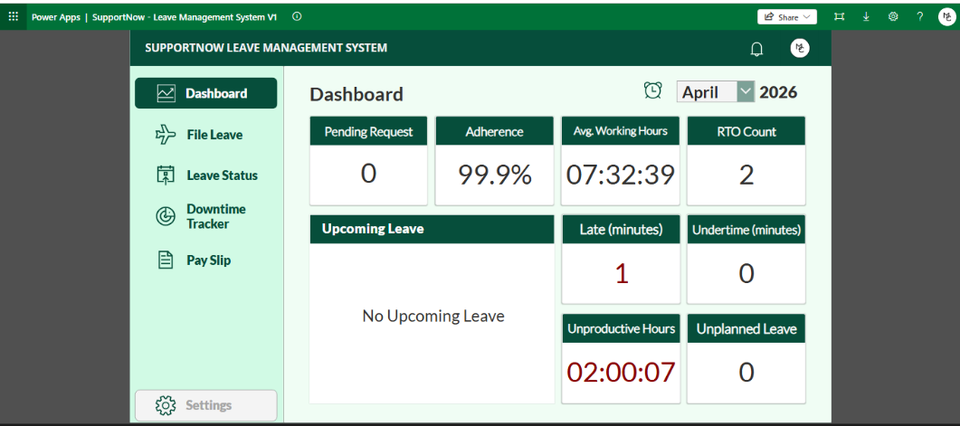
- Current productivity score (Adherence, RTO Count)
6. Submitting a Leave Request
Steps:
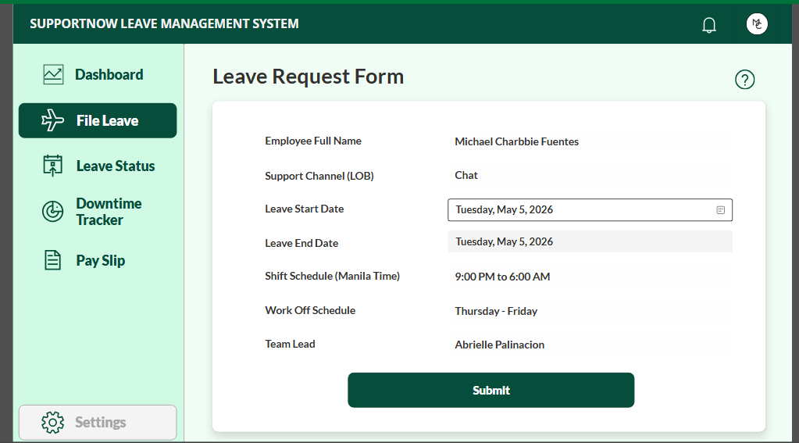
- From the Dashboard, click File Leave.

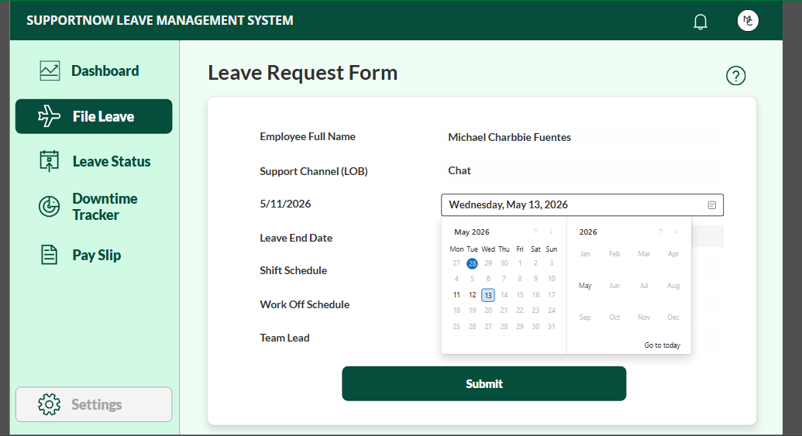
- Select your desired leave date using the Date Picker.


- Click Submit.

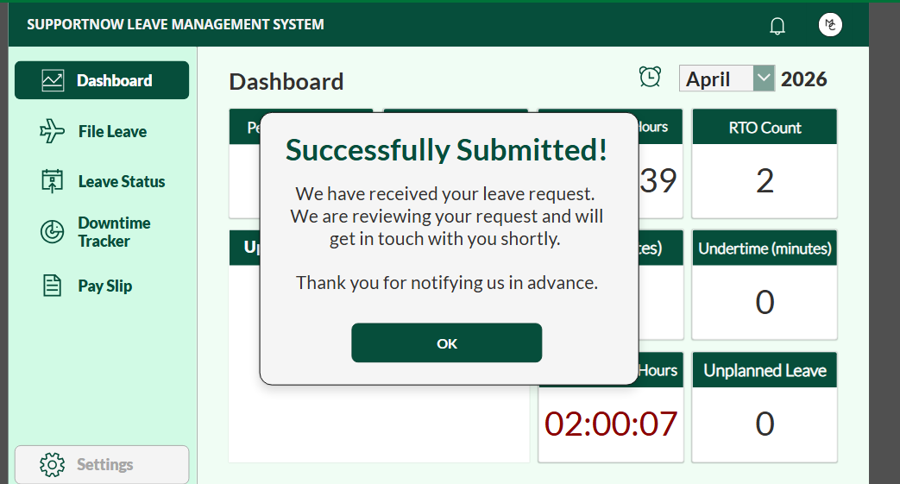
- A confirmation notification will appear once the request is successfully submitted.

Notifications:
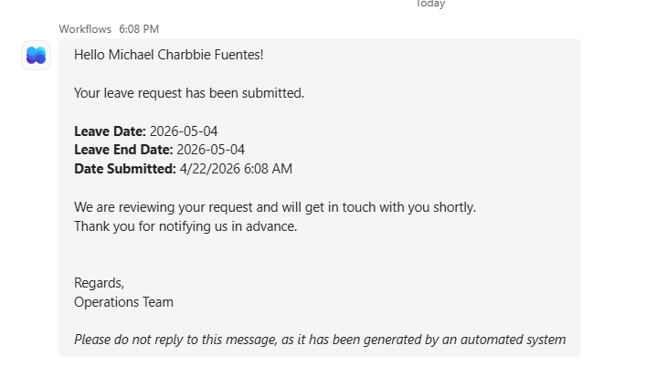
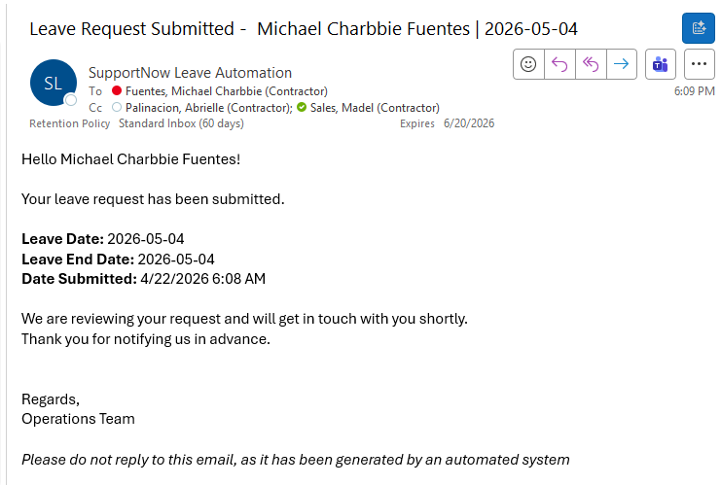
- The agent and the assigned manager will receive both Teams and Email notifications as confirmation.

Important Policy Notes:
- Leave requests must be submitted exactly 14 days before the intended leave date.
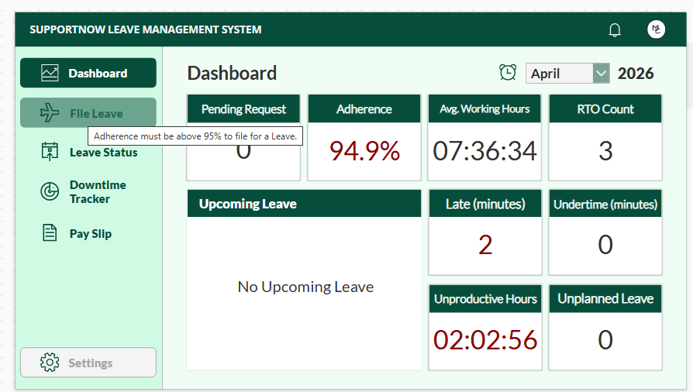
- The File Leave button will be disabled (greyed out) if the agent’s adherence score is below 95%.

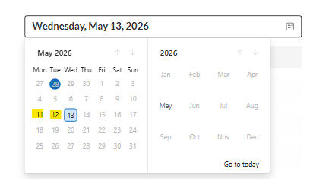
- Once a leave date opens, it remains open only until Sunday of the same week.

7. Leave Date Availability Rules
- Leave dates open on a rolling basis, starting 14 days prior.
- Availability expands daily until Sunday of the applicable week.
- After Sunday, the window closes and moves to the next applicable cycle.

8. Leave Status Tracker
Agents can monitor the progress of their requests under Leave Status:
- Yellow – Pending
- Green – Approved
- Red – Rejected
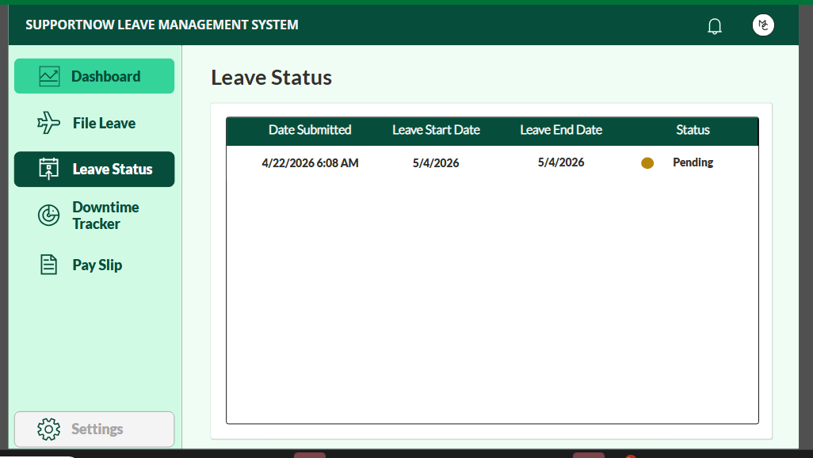
9. Leave Approval Process
- Maximum of two (2) approved leave slots per day during weekdays, and one (1) approved leave during weekends.
- Approval criteria (in priority order):
  - Adherence Score
  - Date of submission (earlier requests have priority)
Automation Logic:
- 1st week: Uses End-of-Month (EOM) Productivity Report
- 2nd – 4th week: Uses Current Productivity Report
- Approval automation runs every Monday and processes requests for the following week.
Example:
- On Monday, April 20, 2026, the system processes leave requests for April 27–May 3, 2026.
Notifications are sent via Teams and Email, with the assigned SME included.
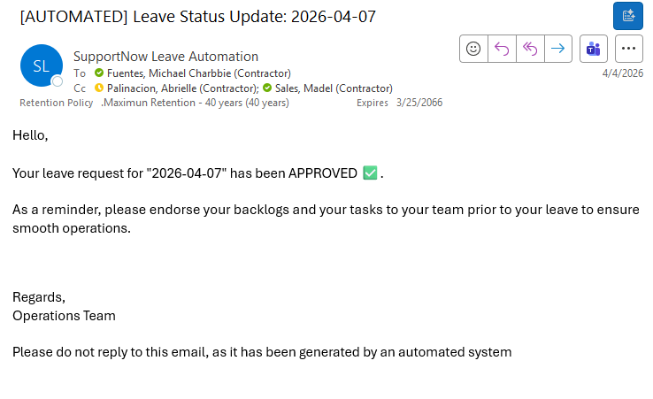
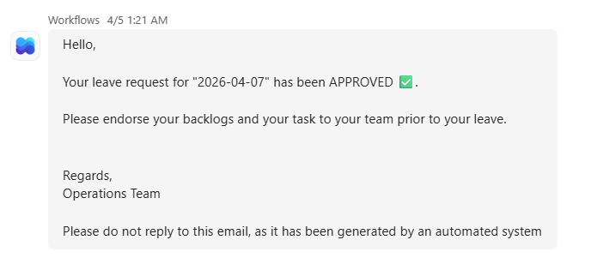

10. Team Dashboard (Manager View)
Managers can access:
- Team leave schedules
- Agent-level and team-level productivity reports
- Planned and approved leaves for capacity planning

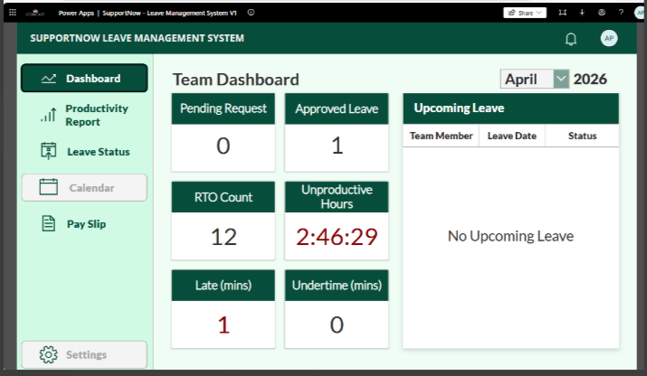
Team – Dashboard

Team – Productivity Report
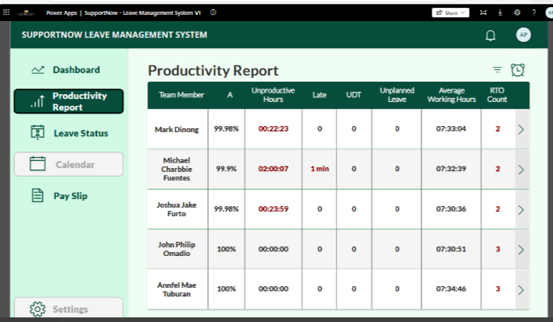

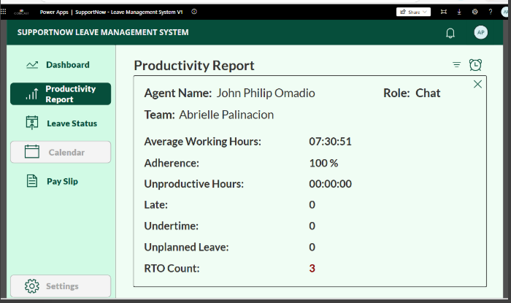
Team – Productivity Report – Agent View

10. Admin Dashboard (Manager View)
Managers can access:
- Team leave schedules
- Agent-level and team-level productivity reports
- Planned and approved leaves for capacity planning

11. Leave Automation Overview
Productivity Data
- Productivity reports are extracted daily from RTA.
Leave Approval Automation
- Runs every Monday before 5:00 PM
- Automatically approves or rejects requests based on defined criteria
- Sends notifications to agents and SMEs/Leads
Leave Reporting Automation
- Generates weekly leave status reports
- Distribute reports to Admin POCs, RTA, and the BEC team
- Includes approved leave for the upcoming week

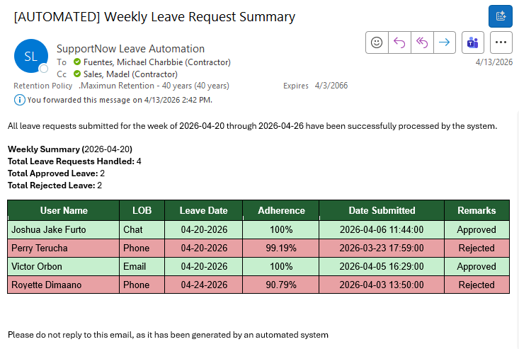
Generated Report – Sent to SME’s/Leads/RTA

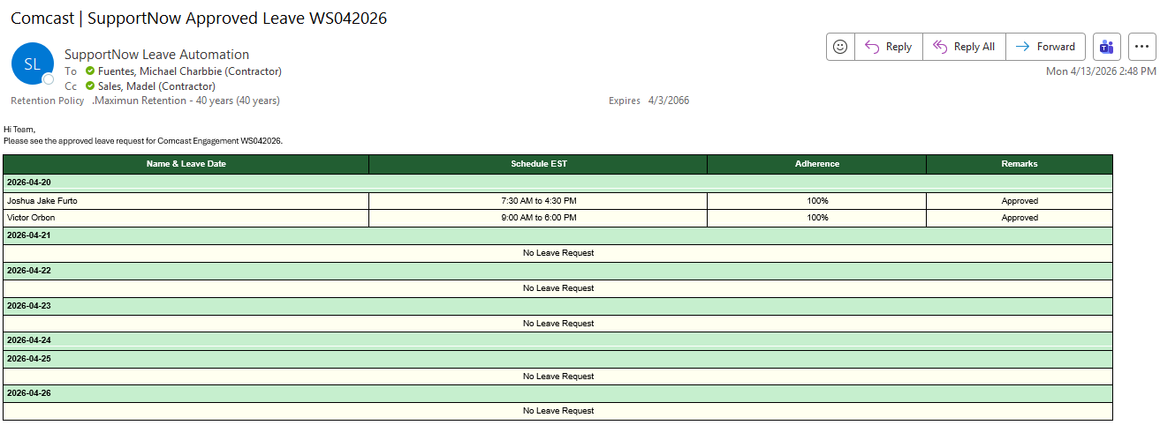
Generated Report – Leads/RTA/BEC

12. Common Issues and Troubleshooting
Issue: Access Error
- Verify SharePoint and Excel permissions
- Sign out and sign in again
Issue: Role Not Recognized
- Refresh the application page
- Coordinate with the Admin POC to confirm your profile is included in the roster file
Issue: No Notification Received
- Refresh the page and check Leave Status
- Confirm status with your SME via the Team Dashboard
- Contact the Admin POC if the issue persists

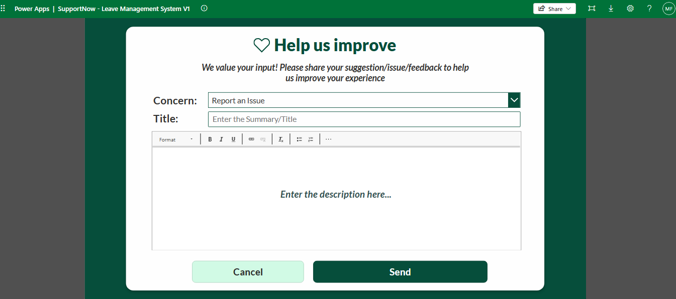

Any other issue, please submit a report from the app support portal.
Report Issue/feedback
13. Contact Support
For assistance, contact:
- Madel Sales
Thank you for using the SupportNow Leave Management System.

